МИНИСТЕРСТВО ОБРАЗОВАНИЯ И НАУКИ РФ
Федеральное государственное бюджетное
образовательное учреждение
высшего образования
ВЯТСКИЙ ГОСУДАРСТВЕННЫЙ УНИВЕРСИТЕТ
ФАКУЛЬТЕТ КОМПЬЮТЕРНЫХ И ФИЗИКО-МАТЕМАТИЧЕСКИХ НАУК
КАФЕДРА ПРИКЛАДНОЙ МАТЕМАТИКИ И ИНФОРМАТИКИ

ОТЧЕТ
ПО ЛАБОРАТОРНОЙ РАБОТЕ №4
по дисциплине
“Компьютерная графика”

ПРИЕМЫ СИНТЕЗА ЛИНЕЙЧАТЫХ ГРАФИЧЕСКИХ УЗОРОВ

Выполнил: студент гр. ФИб-2302-51-00, 2 подгр. Глызин А.С. ___________

Проверила: Декан ФКиФМН Бушмелева Н. А. ___________

Киров 2020
Задание
1. Нарисовать узор из 24 эллипсов с центром узора в середине экрана. Радиусы очередного эллипса (Rx, Ry) и расстояние до центра узора циклически изменять.
2. Нарисовать узор из 20 прямоугольников. Длины сторон прямоугольников и расстояние от центра узора до левого верхнего угла прямоугольника изменять по закону, который обеспечит приемлемый декоративный эффект.
3. Нарисовать узор отрезком прямой, который вращается вокруг своего центра, а этот центр в свою очередь делает один оборот вокруг центра узора.
4. Смоделировать детский калейдоскоп для набора из трех разноцветных "кристаллов" (многоугольников с разным числом углов), размещенных в одном секторе.
5. Смоделировать калейдоскоп с 8 осями симметрии. Смещая при каждом изменении фигуры на пять пикселей диапазон задания координат Х точек исходной ломаной (10 раз увеличивая, затем 10 раз уменьшая), получить пульсирующее движение фигур.
6. Смоделировать вращение узора, полученного из отражений ломаной линии.
7. Смоделировать случайное перемещение узора небольших размеров, полученного из отражений отрезка прямой линии. Контролировать выход узора за границу экрана.
8. Смоделировать работу шестистворчатой диафрагмы объектива.
9. Смоделировать периодически "убегающую внутрь" вращающуюся копию квадрата.
10. Смоделировать "падение в бесконечный водоворот" чередованием перерисовки двух картин уменьшения многоугольника с разными коэффициентами деления сторон.
11. C использованием небольших модификаций процедуры штриховки угла построить следующие фигуры: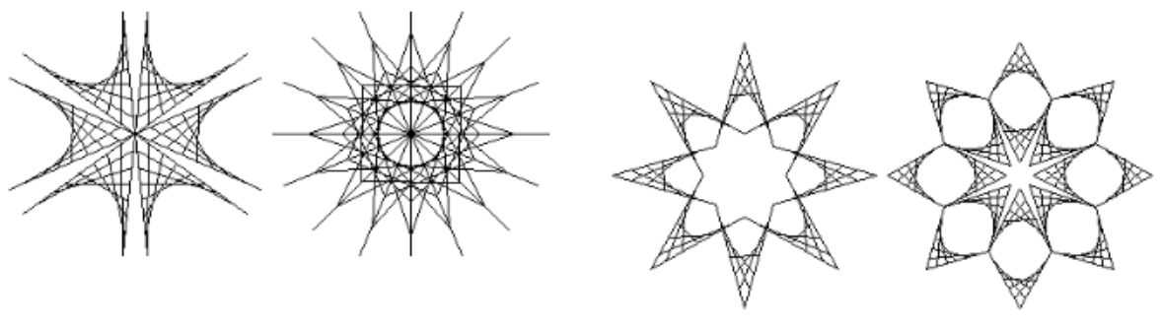

Исходный код программы
1.
void Print(PointF center, float k)
{
Graphics graphics = this.CreateGraphics();
Pen pen = new Pen(Color.FromArgb(146, 69, 255), 1.5f);
float step = 0.03f;
PointF prevPoint = new PointF((float)Math.Sin(0) * k, (float)Math.Cos(0) * k);
for (float a = 0; a < Math.PI * 2; a += step)
{
PointF currentPoint = new PointF((float)Math.Sin(a) * k * 2, (float)Math.Cos(a) * k);
graphics.DrawLine(pen, new PointF(center.X + currentPoint.X, center.Y + currentPoint.Y), new PointF(center.X + prevPoint.X, center.Y + prevPoint.Y));
prevPoint = currentPoint;
}
}
float k2 = 2;
Graphics graphics2 = this.CreateGraphics();
Pen pen2 = new Pen(Color.FromArgb(146, 69, 255), 1.5f);
float step2 = (float)(2*Math.PI/24);
PointF prevPoint2 = new PointF((float)Math.Sin(0) * k2, (float)Math.Cos(0) * k2);
for (float a = 0; a < Math.PI * 2; a += step2)
{
PointF currentPoint = new PointF((float)Math.Sin(a) * k2 * 2, (float)Math.Cos(a) * k2);
Print(new PointF(ClientSize.Width / 2 + currentPoint.X, ClientSize.Height / 2 + currentPoint.Y), k2);
prevPoint2 = currentPoint;
k2+=3;
}
2.
float size = 100;
void Print(PointF leftUpperAngle, float k)
{
Graphics graphics = this.CreateGraphics();
Pen pen = new Pen(Color.FromArgb(146, 69, 255), 1.5f);
float step = 0.03f;
PointF prevPoint = new PointF((float)Math.Sin(0) * k, (float)Math.Cos(0) * k);
graphics.DrawPolygon(pen, new PointF[] { new PointF(leftUpperAngle.X, leftUpperAngle.Y),new PointF(leftUpperAngle.X+size, leftUpperAngle.Y),
new PointF(leftUpperAngle.X + size, leftUpperAngle.Y + size), new PointF(leftUpperAngle.X, leftUpperAngle.Y+size)});
}
float k2 = 80;
Graphics graphics2 = this.CreateGraphics();
Pen pen2 = new Pen(Color.FromArgb(146, 69, 255), 1.5f);
float step2 = (float)(2*Math.PI/20);
PointF prevPoint2 = new PointF((float)Math.Sin(0) * k2, (float)Math.Cos(0) * k2);
for (float a = 0; a < Math.PI * 2; a += step2)
{
PointF currentPoint = new PointF((float)Math.Sin(a) * k2, (float)Math.Cos(a) * k2);
Print(new PointF(ClientSize.Width / 2 + currentPoint.X - size/2, ClientSize.Height / 2 + currentPoint.Y - size/2), k2);
prevPoint2 = currentPoint;
}
3.
float k = 50;
void Print(PointF center)
{
Graphics graphics = this.CreateGraphics();
Pen pen = new Pen(Color.FromArgb(146, 69, 255), 1.5f);
float step = (float)Math.PI*2/30;
PointF prevPoint = new PointF((float)Math.Sin(0) * k, (float)Math.Cos(0) * k);
for (float a = 0; a < Math.PI * 2; a += step)
{
PointF currentPoint = new PointF((float)Math.Sin(a) * k, (float)Math.Cos(a) * k);
graphics.DrawLine(pen, new PointF(center.X + currentPoint.X, center.Y + currentPoint.Y), new PointF(center.X + (float)Math.Sin(a+Math.PI) * k, center.Y + (float)Math.Cos(a + Math.PI) * k));
prevPoint = currentPoint;
}
}
float k2 = 180;
Graphics graphics2 = this.CreateGraphics();
Pen pen2 = new Pen(Color.FromArgb(146, 69, 255), 1.5f);
float step2 = (float)(2 * Math.PI / 20);
PointF prevPoint2 = new PointF((float)Math.Sin(0) * k2, (float)Math.Cos(0) * k2);
for (float a = 0; a < Math.PI * 2; a += step2)
{
PointF currentPoint = new PointF((float)Math.Sin(a) * k2, (float)Math.Cos(a) * k2);

Print(new PointF(ClientSize.Width / 2 + currentPoint.X, ClientSize.Height / 2 + currentPoint.Y));
prevPoint2 = currentPoint;
}
4.
Graphics graphics = this.CreateGraphics();
Pen pen = new Pen(Color.FromArgb(146, 69, 255), 1.5f);
float k = 150;
float step = (float)Math.PI*2/3;
PointF currentPoint;
float a = offset;
PointF prevPoint = new PointF((float)Math.Sin(a) * k, (float)Math.Cos(a) * k);
for (; a < Math.PI * 2 + offset; a += step)
{
currentPoint = new PointF((float)Math.Sin(a) * k, (float)Math.Cos(a) * k);
graphics.DrawLine(pen, new PointF(center.X + currentPoint.X, center.Y + currentPoint.Y), new PointF(center.X + prevPoint.X, center.Y + prevPoint.Y));
prevPoint = currentPoint;
}
currentPoint = new PointF((float)Math.Sin(a) * k, (float)Math.Cos(a) * k);
graphics.DrawLine(pen, new PointF(center.X + currentPoint.X, center.Y + currentPoint.Y), new PointF(center.X + prevPoint.X, center.Y + prevPoint.Y));

k = 55;
step = (float)Math.PI * 2 / 5;
a = offset;
prevPoint = new PointF((float)Math.Sin(a) * k, (float)Math.Cos(a) * k);
for (; a < Math.PI * 2 + offset; a += step)
{
currentPoint = new PointF((float)Math.Sin(a) * k, (float)Math.Cos(a) * k);
graphics.DrawLine(pen, new PointF(center.X + currentPoint.X, center.Y + currentPoint.Y), new PointF(center.X + prevPoint.X, center.Y + prevPoint.Y));
prevPoint = currentPoint;
}
currentPoint = new PointF((float)Math.Sin(a) * k, (float)Math.Cos(a) * k);
graphics.DrawLine(pen, new PointF(center.X + currentPoint.X, center.Y + currentPoint.Y), new PointF(center.X + prevPoint.X, center.Y + prevPoint.Y));

k = 95;
step = (float)Math.PI * 2 / 4;
a = offset;
prevPoint = new PointF((float)Math.Sin(a) * k, (float)Math.Cos(a) * k);
for (; a < Math.PI * 2 + offset; a += step)
{
currentPoint = new PointF((float)Math.Sin(a) * k, (float)Math.Cos(a) * k);
graphics.DrawLine(pen, new PointF(center.X + currentPoint.X, center.Y + currentPoint.Y), new PointF(center.X + prevPoint.X, center.Y + prevPoint.Y));
prevPoint = currentPoint;
}
currentPoint = new PointF((float)Math.Sin(a) * k, (float)Math.Cos(a) * k);
graphics.DrawLine(pen, new PointF(center.X + currentPoint.X, center.Y + currentPoint.Y), new PointF(center.X + prevPoint.X, center.Y + prevPoint.Y));

}
float k2 = 180;
Graphics graphics2 = this.CreateGraphics();
Pen pen2 = new Pen(Color.FromArgb(146, 69, 255), 1.5f);
float step2 = (float)(2 * Math.PI / 6);
float _offset = 0;
PointF prevPoint2 = new PointF((float)Math.Sin(0) * k2, (float)Math.Cos(0) * k2);
for (float a = (float)Math.PI; a < Math.PI * 2 + Math.PI/1.5; a += step2)
{
PointF currentPoint = new PointF((float)Math.Sin(a) * k2, (float)Math.Cos(a) * k2);
//graphics2.DrawLine(pen2, new PointF(ClientSize.Width / 2 + currentPoint.X, ClientSize.Height / 2 + currentPoint.Y), new PointF(ClientSize.Width / 2, ClientSize.Height / 2));
Print(new PointF(ClientSize.Width / 2+ currentPoint.X, ClientSize.Height / 2 + currentPoint.Y), _offset);
prevPoint2 = currentPoint;
_offset += (float) Math.PI / 3;
}
5.
int animationStep = 1;
bool reverse = false;

private void timer1_Tick(object sender, EventArgs e)
{
void Print(PointF center, float offset, float size)
{

Graphics graphics = this.CreateGraphics();
Pen pen = new Pen(Color.FromArgb(146, 69, 255), 1.5f);
float k = 2 * size;
float step = (float)Math.PI * 2 / 3;
PointF currentPoint;
float a = offset;
PointF prevPoint = new PointF((float)Math.Sin(a) * k, (float)Math.Cos(a) * k);
for (; a < Math.PI * 2 + offset; a += step)
{
currentPoint = new PointF((float)Math.Sin(a) * k, (float)Math.Cos(a) * k);
graphics.DrawLine(pen, new PointF(center.X + currentPoint.X, center.Y + currentPoint.Y), new PointF(center.X + prevPoint.X, center.Y + prevPoint.Y));
prevPoint = currentPoint;
}
currentPoint = new PointF((float)Math.Sin(a) * k, (float)Math.Cos(a) * k);
graphics.DrawLine(pen, new PointF(center.X + currentPoint.X, center.Y + currentPoint.Y), new PointF(center.X + prevPoint.X, center.Y + prevPoint.Y));

k = 1 * size;
step = (float)Math.PI * 2 / 5;
a = offset;
prevPoint = new PointF((float)Math.Sin(a) * k, (float)Math.Cos(a) * k);
for (; a < Math.PI * 2 + offset; a += step)
{
currentPoint = new PointF((float)Math.Sin(a) * k, (float)Math.Cos(a) * k);
graphics.DrawLine(pen, new PointF(center.X + currentPoint.X, center.Y + currentPoint.Y), new PointF(center.X + prevPoint.X, center.Y + prevPoint.Y));
prevPoint = currentPoint;
}
currentPoint = new PointF((float)Math.Sin(a) * k, (float)Math.Cos(a) * k);
graphics.DrawLine(pen, new PointF(center.X + currentPoint.X, center.Y + currentPoint.Y), new PointF(center.X + prevPoint.X, center.Y + prevPoint.Y));

k = 3.5f * size;
step = (float)Math.PI * 2 / 4;
a = offset;
prevPoint = new PointF((float)Math.Sin(a) * k, (float)Math.Cos(a) * k);
for (; a < Math.PI * 2 + offset; a += step)
{
currentPoint = new PointF((float)Math.Sin(a) * k, (float)Math.Cos(a) * k);
graphics.DrawLine(pen, new PointF(center.X + currentPoint.X, center.Y + currentPoint.Y), new PointF(center.X + prevPoint.X, center.Y + prevPoint.Y));
prevPoint = currentPoint;
}
currentPoint = new PointF((float)Math.Sin(a) * k, (float)Math.Cos(a) * k);
graphics.DrawLine(pen, new PointF(center.X + currentPoint.X, center.Y + currentPoint.Y), new PointF(center.X + prevPoint.X, center.Y + prevPoint.Y));

}
if (animationStep >= 10)
reverse = true; else
if (animationStep <= 1)
reverse = false;
if (reverse)
animationStep--; else
animationStep++;
float k2 = 180;
Graphics graphics2 = this.CreateGraphics();
graphics2.Clear(Color.FromArgb(20, 20, 20));
Pen pen2 = new Pen(Color.FromArgb(146, 69, 255), 1.5f);
int symmetryCount = 8;
float step2 = (float)(2 * Math.PI / symmetryCount);
float _offset = 0;
PointF prevPoint2 = new PointF((float)Math.Sin(0) * k2, (float)Math.Cos(0) * k2);
int counter = 0;
for (float a = (float)Math.PI; a < Math.PI * 2 + Math.PI; a += step2)
{
PointF currentPoint = new PointF((float)Math.Sin(a) * k2, (float)Math.Cos(a) * k2);
//graphics2.DrawLine(pen2, new PointF(ClientSize.Width / 2 + currentPoint.X, ClientSize.Height / 2 + currentPoint.Y), new PointF(ClientSize.Width / 2, ClientSize.Height / 2));
Print(new PointF(ClientSize.Width / 2 + currentPoint.X, ClientSize.Height / 2 + currentPoint.Y), _offset, ((counter % 2 != 0) ? 5f : 3f)* animationStep);
prevPoint2 = currentPoint;
_offset += (float)Math.PI / (symmetryCount / 2);
counter++;
}
}
6.
float animationStep = 0;

private void timer1_Tick(object sender, EventArgs e)
{
void Print(PointF center, float offset, float size)
{

Graphics graphics = this.CreateGraphics();
Pen pen = new Pen(Color.FromArgb(146, 69, 255), 1.5f);
float k = 2 * size;
float step = (float)Math.PI * 2 / 3;
PointF currentPoint;
float a = offset;
PointF prevPoint = new PointF((float)Math.Sin(a) * k, (float)Math.Cos(a) * k);
for (; a < Math.PI * 2 + offset; a += step)
{
currentPoint = new PointF((float)Math.Sin(a) * k, (float)Math.Cos(a) * k);
graphics.DrawLine(pen, new PointF(center.X + currentPoint.X, center.Y + currentPoint.Y), new PointF(center.X + prevPoint.X, center.Y + prevPoint.Y));
prevPoint = currentPoint;
}
currentPoint = new PointF((float)Math.Sin(a) * k, (float)Math.Cos(a) * k);
graphics.DrawLine(pen, new PointF(center.X + currentPoint.X, center.Y + currentPoint.Y), new PointF(center.X + prevPoint.X, center.Y + prevPoint.Y));

k = 1 * size;
step = (float)Math.PI * 2 / 5;
a = offset;
prevPoint = new PointF((float)Math.Sin(a) * k, (float)Math.Cos(a) * k);
for (; a < Math.PI * 2 + offset; a += step)
{
currentPoint = new PointF((float)Math.Sin(a) * k, (float)Math.Cos(a) * k);
graphics.DrawLine(pen, new PointF(center.X + currentPoint.X, center.Y + currentPoint.Y), new PointF(center.X + prevPoint.X, center.Y + prevPoint.Y));
prevPoint = currentPoint;
}
currentPoint = new PointF((float)Math.Sin(a) * k, (float)Math.Cos(a) * k);
graphics.DrawLine(pen, new PointF(center.X + currentPoint.X, center.Y + currentPoint.Y), new PointF(center.X + prevPoint.X, center.Y + prevPoint.Y));

k = 2.5f * size;
step = (float)Math.PI * 2 / 4;
a = offset;
prevPoint = new PointF((float)Math.Sin(a) * k, (float)Math.Cos(a) * k);
for (; a < Math.PI * 2 + offset; a += step)
{
currentPoint = new PointF((float)Math.Sin(a) * k, (float)Math.Cos(a) * k);
graphics.DrawLine(pen, new PointF(center.X + currentPoint.X, center.Y + currentPoint.Y), new PointF(center.X + prevPoint.X, center.Y + prevPoint.Y));
prevPoint = currentPoint;
}
currentPoint = new PointF((float)Math.Sin(a) * k, (float)Math.Cos(a) * k);
graphics.DrawLine(pen, new PointF(center.X + currentPoint.X, center.Y + currentPoint.Y), new PointF(center.X + prevPoint.X, center.Y + prevPoint.Y));

}
if (animationStep > Math.PI*2)
animationStep = 0;
animationStep+=0.1f;
float k2 = 180;
Graphics graphics2 = this.CreateGraphics();
graphics2.Clear(Color.FromArgb(20, 20, 20));
Pen pen2 = new Pen(Color.FromArgb(146, 69, 255), 1.5f);
int symmetryCount = 8;
float step2 = (float)(2 * Math.PI / symmetryCount);
float _offset = 0;
PointF prevPoint2 = new PointF((float)Math.Sin(0) * k2, (float)Math.Cos(0) * k2);
int counter = 0;
for (float a = (float)Math.PI + animationStep; a < Math.PI * 2 + Math.PI + animationStep; a += step2)
{
PointF currentPoint = new PointF((float)Math.Sin(a) * k2, (float)Math.Cos(a) * k2);
Print(new PointF(ClientSize.Width / 2 + currentPoint.X, ClientSize.Height / 2 + currentPoint.Y), _offset, /*((counter % 2 != 0) ? 5f : 3f)* animationStep*/30);
prevPoint2 = currentPoint;
_offset += (float)Math.PI / (symmetryCount / 2);
counter++;
}
}
7.
float maxSize = float.MinValue;
bool Print(PointF centePh)
{
float k = 5;
Graphics methodGraph = this.CreateGraphics();
Pen methodPen = new Pen(Color.FromArgb(146, 69, 255), 1.5f);
float methodStep = (float)Math.PI * 2 /6;
PointF methodPrevPoint = new PointF((float)Math.Sin(0) * k, (float)Math.Cos(0) * k);
for (float methodA = 0; methodA < Math.PI * 2; methodA += methodStep)
{
PointF methodCurrentPoint = new PointF((float)Math.Sin(methodA) * k, (float)Math.Cos(methodA) * k);
if (methodCurrentPoint.X > maxSize)
{
maxSize = methodCurrentPoint.X*2 + methodCurrentPoint.X/2;
}
methodGraph.DrawLine(methodPen, new PointF(centePh.X + methodCurrentPoint.X, centePh.Y + methodCurrentPoint.Y), new PointF(centePh.X + (float)Math.Sin(methodA + Math.PI) * k, centePh.Y + (float)Math.Cos(methodA + Math.PI) * k));
methodPrevPoint = methodCurrentPoint;
}
return true;
}

Random random = new Random();
float GetRandomNumber(double minimum, double maximum)
{
return (float)(random.NextDouble() * (maximum - minimum) + minimum);
}
Graphics graphics = this.CreateGraphics();
Pen pen = new Pen(Color.FromArgb(146, 69, 255), 1.5f);

float a = GetRandomNumber(0.1, 1f);
PointF center = new PointF(ClientSize.Width/2, ClientSize.Height/2);
float x = 0;
float y = -(x * a);
int yMark = 1;
float step = 10f;
float lastCorrectX = x;
int counter = 0;
PointF currentPoint = new PointF(center.X + x, center.Y + y);
bool correct = true;
int uncorrectCount = 0;
while (true)
{
while (correct)
{
Thread.Sleep(10);
x += step;
y = -(x * a * yMark);
currentPoint = new PointF(center.X + x, center.Y + y);
Print(currentPoint);

if (currentPoint.X < ClientSize.Width- maxSize && currentPoint.X > maxSize && currentPoint.Y < ClientSize.Height - maxSize && currentPoint.Y > maxSize)
{
correct = true;
}
else
{
correct = false;
x -= step;
}
}
if (!(currentPoint.Y > maxSize))
{
yMark *= -1;
}
if (!(currentPoint.X < ClientSize.Width- maxSize))
{
step *= -1;
yMark *= -1;
}
if (!(currentPoint.Y < ClientSize.Height- maxSize))
{
yMark *= -1;
}
if (!(currentPoint.X > maxSize))
{
step *= -1;
yMark *= -1;
}
x = 0;
uncorrectCount++;

correct = true;
center = currentPoint;
a = GetRandomNumber(0.1, 1f);
counter++;
}
8.
PointF center = new PointF(ClientSize.Width / 2, ClientSize.Height / 2);
Graphics graphics = this.CreateGraphics();
Pen penCirlce = new Pen(Color.FromArgb(146, 69, 255), 1.5f);
Pen background = new Pen(Color.FromArgb(20, 20, 20), 1.5f);
float a = 0;
float k = 250;
int counter = 0;
float step = 30;
float currentSize = k;
float _offset = 0;
float range = 30;
PointF[] prevPoints = new PointF[7];
void Draw(float offset, float size, Pen pen, bool reverse)
{
PointF currentPoint;
PointF prevPoint = new PointF((float)Math.Cos(a) * k + center.X, (float)Math.Sin(a) * k + center.Y);
for (; a < Math.PI * 2;)
{
a += (float)Math.PI / (k / 2);
currentPoint = new PointF((float)Math.Cos(a) * k + center.X, (float)Math.Sin(a) * k + center.Y);
graphics.DrawLine(penCirlce, prevPoint, currentPoint);
prevPoint = currentPoint;
}
Pen _pen = new Pen(Color.FromArgb(146, 69, 255), 1.5f);
PointF _enter = new PointF(ClientSize.Width / 2, ClientSize.Height / 2);
float _a = offset;
float _k = size;
PointF _currentPoint;
PointF _prevPoint = new PointF((float)Math.Cos(_a) * _k + center.X, (float)Math.Sin(_a) * _k + center.Y);
int index = 0;
for (; _a < Math.PI * 2 + offset;)
{
_a += (float)Math.PI / 3;
_currentPoint = new PointF((float)Math.Cos(_a) * _k + center.X, (float)Math.Sin(_a) * _k + center.Y);
if (index != 6 && !reverse)
{
if (k != size && pen != background)
{
graphics.DrawLine(pen, _prevPoint, prevPoints[index]);
}
if (pen != background)
{
prevPoints[index] = _prevPoint;
}
}
if (index != 6 && reverse)
{
PointF nextPoint = new PointF((float)Math.Cos(_a+ Math.PI / range) * (_k- step) + center.X, (float)Math.Sin(_a+ Math.PI / range) * (_k - step) + center.Y);
graphics.DrawLine(background, nextPoint, _currentPoint);
}
graphics.DrawLine(pen, _prevPoint, _currentPoint);
_prevPoint = _currentPoint;
index++;
}
}

while (currentSize > 30)
{
this.Invalidate();
if (currentSize - step > 30)
Draw(_offset, currentSize, penCirlce, false);
Thread.Sleep(10);
Draw(_offset, currentSize, background, false);
_offset += (float)Math.PI / range;
currentSize -= step;
}

while (currentSize < k)
{
if (currentSize > 40)
Draw(_offset, currentSize, penCirlce, true);
Thread.Sleep(10);
Draw(_offset, currentSize, background, true);
_offset -= (float)Math.PI / range;
currentSize += step;
}
9.
PointF center = new PointF(ClientSize.Width / 2, ClientSize.Height / 2);
Graphics graphics = this.CreateGraphics();
Pen mainPen = new Pen(Color.FromArgb(146, 69, 255), 1.5f);
Pen background = new Pen(Color.FromArgb(20, 20, 20), 1.5f);
const float maxSize = 140;
void Draw(Pen pen, float offset, float size)
{
PointF currentPoint = new PointF();
float step = (float)Math.PI / 2;
float a = step + offset;
PointF prevPoint = new PointF((float)Math.Cos(a) * size + center.X, (float)Math.Sin(a) * size + center.Y);
for (; a < Math.PI*2 + step + offset;)
{
a += step;
currentPoint = new PointF((float)Math.Cos(a)* size + center.X, (float)Math.Sin(a)* size + center.Y);
graphics.DrawLine(pen, currentPoint, prevPoint);
prevPoint = currentPoint;
}
}
float offsetStep = (float)Math.PI * 2 / maxSize;
float currentOffset = (float)Math.PI / 4;
this.Invalidate();
Draw(mainPen, (float)Math.PI / 4, maxSize);
for (float i = maxSize; i > 0; i-=7)
{
Draw(mainPen, currentOffset, i);
currentOffset += offsetStep;
Thread.Sleep(100);
}
10.
PointF center = new PointF(ClientSize.Width / 2, ClientSize.Height / 2);
Graphics graphics = this.CreateGraphics();
Pen mainPen = new Pen(Color.FromArgb(146, 69, 255), 1.5f);
Pen background = new Pen(Color.FromArgb(20, 20, 20), 1.5f);
const float maxSize = 140;
void Draw(Pen pen, float offset, float size, PointF coefficient)
{
PointF currentPoint = new PointF();
float step = (float)Math.PI / 2;
float a = step + offset;
PointF prevPoint = new PointF((float)Math.Cos(a) * size * coefficient.X + center.X, (float)Math.Sin(a) * size * coefficient.Y + center.Y);
for (; a < Math.PI * 2 + step + offset;)
{
a += step;
currentPoint = new PointF((float)Math.Cos(a) * size * coefficient.X + center.X, (float)Math.Sin(a) * size * coefficient.Y + center.Y);
graphics.DrawLine(pen, currentPoint, prevPoint);
prevPoint = currentPoint;
}
}
float offsetStep = (float)Math.PI * 2 / maxSize;
float currentOffset = (float)Math.PI / 4;
this.Invalidate();
Draw(mainPen, (float)Math.PI / 4, maxSize, new PointF(1,1));
for (float i = maxSize; i > 0; i -= 10)
{
Draw(mainPen, currentOffset, i, new PointF(0.9f,0.6f));
currentOffset += offsetStep;
Thread.Sleep(100);
}
11.
a)
PointF center = new PointF(ClientSize.Width / 2, ClientSize.Height / 2);
Graphics graphics = this.CreateGraphics();
Pen mainPen = new Pen(Color.FromArgb(146, 69, 255), 1.5f);
Pen background = new Pen(Color.FromArgb(20, 20, 20), 1.5f);
float angleCount = 6;
float indentation = (float)Math.PI / 30;
float k = 200;
int shadeCount = 10;

void ShadeAngle(List<PointF> points)
{
PointF[] points1 = new PointF[shadeCount];
float xStep = (points[1].X - points[0].X) / shadeCount;
float yStep = (points[1].Y - points[0].Y) / shadeCount;
for (int i = 0; i < shadeCount; i++)
{
points1[i] = new PointF(points[0].X + xStep * i, points[0].Y + yStep * i);
}
PointF[] points2 = new PointF[shadeCount];
xStep = (points[1].X - points[2].X) / shadeCount;
yStep = (points[1].Y - points[2].Y) / shadeCount;
for (int i = 0; i < shadeCount; i++)
{
points2[i] = new PointF(points[2].X + xStep * i, points[2].Y + yStep * i);
}
for (int i = 0; i < shadeCount; i++)
{
graphics.DrawLine(new Pen(Color.White, 1f), points1[i], points2[shadeCount - i - 1]);
}
}

void Draw()
{
PointF currentPoint = new PointF();
float step = (float)Math.PI / (angleCount / 2);
float a = step;
PointF prevPoint = new PointF((float)Math.Cos(a) * k + center.X, (float)Math.Sin(a) * k + center.Y);
for (; a < Math.PI * 2 + step;)
{
a += step;
currentPoint = new PointF((float)Math.Cos(a) * k + center.X, (float)Math.Sin(a) * k + center.Y);
//graphics.DrawLine(mainPen, currentPoint, prevPoint);
List<PointF> points = new List<PointF>();
points.Add(new PointF((float)Math.Cos(a - step / 2 + indentation) * k + center.X, (float)Math.Sin(a - step / 2 + indentation) * k + center.Y));
points.Add(center);
points.Add(new PointF((float)Math.Cos(a + step / 2 - indentation) * k + center.X, (float)Math.Sin(a + step / 2 - indentation) * k + center.Y));
ShadeAngle(points);
graphics.DrawLine(mainPen, points[1], points[0]);
graphics.DrawLine(mainPen, points[1], points[2]);
prevPoint = currentPoint;
}
}
Draw();
b)
PointF center = new PointF(ClientSize.Width / 2, ClientSize.Height / 2);
Graphics graphics = this.CreateGraphics();
Pen mainPen = new Pen(Color.FromArgb(146, 69, 255), 1.5f);
Pen background = new Pen(Color.FromArgb(20, 20, 20), 1.5f);
float angleCount = 16;
float indentation = (float)Math.PI / 30;
float k = 200;
float k2 = 150;
float k3 = 50;
int shadeCount = 5;
void ShadeAngle(List<PointF> points)
{
PointF[] points1 = new PointF[shadeCount];
float xStep = (points[1].X - points[0].X) / shadeCount;
float yStep = (points[1].Y - points[0].Y) / shadeCount;
for (int i = 0; i < shadeCount; i++)
{
points1[i] = new PointF(points[0].X + xStep * i, points[0].Y + yStep * i);
}
PointF[] points2 = new PointF[shadeCount];
xStep = (points[1].X - points[2].X) / shadeCount;
yStep = (points[1].Y - points[2].Y) / shadeCount;
for (int i = 0; i < shadeCount; i++)
{
points2[i] = new PointF(points[2].X + xStep * i, points[2].Y + yStep * i);
}
for (int i = 0; i < shadeCount; i++)
{
graphics.DrawLine(mainPen, points1[i], points2[shadeCount - i - 1]);
}
}
void Draw()
{
PointF currentPoint = new PointF();
float step = (float)Math.PI / (angleCount / 2);
float a = step;
PointF prevPoint = new PointF((float)Math.Cos(a) * k + center.X, (float)Math.Sin(a) * k + center.Y);
for (; a < Math.PI * 2 + step;)
{
a += step;
graphics.DrawLine(mainPen, center, prevPoint);
currentPoint = new PointF((float)Math.Cos(a) * k2 + center.X, (float)Math.Sin(a) * k2 + center.Y);
prevPoint = new PointF((float)Math.Cos(a- step) * k2 + center.X, (float)Math.Sin(a- step) * k2 + center.Y);
List<PointF> points = new List<PointF>();
for (int i = 0; i < 3; i++) points.Add(new PointF());
points[1]=prevPoint;
currentPoint = new PointF((float)Math.Cos(a + Math.PI/2) * k3 + center.X, (float)Math.Sin(a + Math.PI/2) * k3 + center.Y);
graphics.DrawLine(mainPen, points[1], currentPoint);
points[0] = currentPoint;
currentPoint = new PointF((float)Math.Cos(a- step*2 - Math.PI / 2) * k3 + center.X, (float)Math.Sin(a - step*2 - Math.PI / 2) * k3 + center.Y);
graphics.DrawLine(mainPen, points[1], currentPoint);
points[2] = currentPoint;
ShadeAngle(points);
currentPoint = new PointF((float)Math.Cos(a) * k + center.X, (float)Math.Sin(a) * k + center.Y);
prevPoint = currentPoint;
}
}
Draw();
c)
PointF center = new PointF(ClientSize.Width / 2, ClientSize.Height / 2);
Graphics graphics = this.CreateGraphics();
Pen mainPen = new Pen(Color.FromArgb(146, 69, 255), 1.5f);
Pen background = new Pen(Color.FromArgb(20, 20, 20), 1.5f);
float angleCount = 8;
float k = 200;
float k2 = 70;
int shadeCount = 10;
void ShadeAngle(List<PointF> points)
{
PointF[] points1 = new PointF[shadeCount];
float xStep = (points[1].X - points[0].X) / shadeCount;
float yStep = (points[1].Y - points[0].Y) / shadeCount;
for (int i = 0; i < shadeCount; i++)
{
points1[i] = new PointF(points[0].X + xStep * i, points[0].Y + yStep * i);
}
PointF[] points2 = new PointF[shadeCount];
xStep = (points[1].X - points[2].X) / shadeCount;
yStep = (points[1].Y - points[2].Y) / shadeCount;
for (int i = 0; i < shadeCount; i++)
{
points2[i] = new PointF(points[2].X + xStep * i, points[2].Y + yStep * i);
}
for (int i = 0; i < shadeCount; i++)
{
graphics.DrawLine(mainPen, points1[i], points2[shadeCount - i - 1]);
}
}
void Draw()
{
PointF currentPoint = new PointF();
float step = (float)Math.PI / (angleCount / 2);
float a = step;
PointF prevPoint = new PointF((float)Math.Cos(a) * k + center.X, (float)Math.Sin(a) * k + center.Y);
for (; a < Math.PI * 2 + step;)
{
a += step;
//graphics.DrawLine(mainPen, center, prevPoint);
currentPoint = new PointF((float)Math.Cos(a) * k + center.X, (float)Math.Sin(a) * k + center.Y);

List<PointF> points = new List<PointF>();
for (int i = 0; i < 3; i++) points.Add(new PointF());
points[1] = prevPoint;
currentPoint = new PointF((float)Math.Cos(a) * k2 + center.X, (float)Math.Sin(a) * k2 + center.Y);
graphics.DrawLine(mainPen, points[1], currentPoint);
points[0] = currentPoint;
//currentPoint = new PointF((float)Math.Cos(a - step * 2 - Math.PI / 2) * k3 + center.X, (float)Math.Sin(a - step * 2 - Math.PI / 2) * k3 + center.Y);
//graphics.DrawLine(mainPen, points[1], currentPoint);
currentPoint = new PointF((float)Math.Cos(a - step * 2) * k2 + center.X, (float)Math.Sin(a - step*2) * k2 + center.Y);
graphics.DrawLine(mainPen, points[1], currentPoint);
points[2] = currentPoint;
ShadeAngle(points);
currentPoint = new PointF((float)Math.Cos(a) * k + center.X, (float)Math.Sin(a) * k + center.Y);

currentPoint = new PointF((float)Math.Cos(a) * k + center.X, (float)Math.Sin(a) * k + center.Y);
prevPoint = currentPoint;
}
}
Draw();
d)
PointF center = new PointF(ClientSize.Width / 2, ClientSize.Height / 2);
Graphics graphics = this.CreateGraphics();
Pen mainPen = new Pen(Color.FromArgb(146, 69, 255), 1.5f);
Pen background = new Pen(Color.FromArgb(20, 20, 20), 1.5f);
float angleCount = 8;
float k1 = 280;
float k2 = 180;
float k3 = 30;
int shadeCount = 10;
void ShadeAngle(List<PointF> points)
{
PointF[] points1 = new PointF[shadeCount];
float xStep = (points[1].X - points[0].X) / shadeCount;
float yStep = (points[1].Y - points[0].Y) / shadeCount;
for (int i = 0; i < shadeCount; i++)
{
points1[i] = new PointF(points[0].X + xStep * i, points[0].Y + yStep * i);
}
PointF[] points2 = new PointF[shadeCount];
xStep = (points[1].X - points[2].X) / shadeCount;
yStep = (points[1].Y - points[2].Y) / shadeCount;
for (int i = 0; i < shadeCount; i++)
{
points2[i] = new PointF(points[2].X + xStep * i, points[2].Y + yStep * i);
}
for (int i = 0; i < shadeCount; i++)
{
graphics.DrawLine(mainPen, points1[i], points2[shadeCount - i - 1]);
}
}
void Draw()
{
PointF currentPoint = new PointF();
float step = (float)Math.PI / (angleCount / 2);
float a = step;
PointF prevPoint = new PointF((float)Math.Cos(a) * k1 + center.X, (float)Math.Sin(a) * k1 + center.Y);
for (; a < Math.PI * 2 + step;)
{
a += step;
currentPoint = new PointF((float)Math.Cos(a) * k1 + center.X, (float)Math.Sin(a) * k1 + center.Y);
List<PointF> points = new List<PointF>();
for (int i = 0; i < 3; i++) points.Add(new PointF());
points[1] = prevPoint;
currentPoint = new PointF((float)Math.Cos(a - step*1.5) * k2 + center.X, (float)Math.Sin(a - step * 1.5) * k2 + center.Y);
graphics.DrawLine(mainPen, points[1], currentPoint);
points[0] = currentPoint;
currentPoint = new PointF((float)Math.Cos(a - step/2) * k2 + center.X, (float)Math.Sin(a - step / 2) * k2 + center.Y);
graphics.DrawLine(mainPen, points[1], currentPoint);
points[2] = currentPoint;
ShadeAngle(points);
currentPoint = new PointF((float)Math.Cos(a - step) * k3 + center.X, (float)Math.Sin(a - step) * k3 + center.Y);
graphics.DrawLine(mainPen, points[0], currentPoint);
graphics.DrawLine(mainPen, points[2], currentPoint);
points[1] = currentPoint;
ShadeAngle(points);
currentPoint = new PointF((float)Math.Cos(a) * k1 + center.X, (float)Math.Sin(a) * k1 + center.Y);
prevPoint = currentPoint;
}
}
Draw();

Результаты работы программы
1. 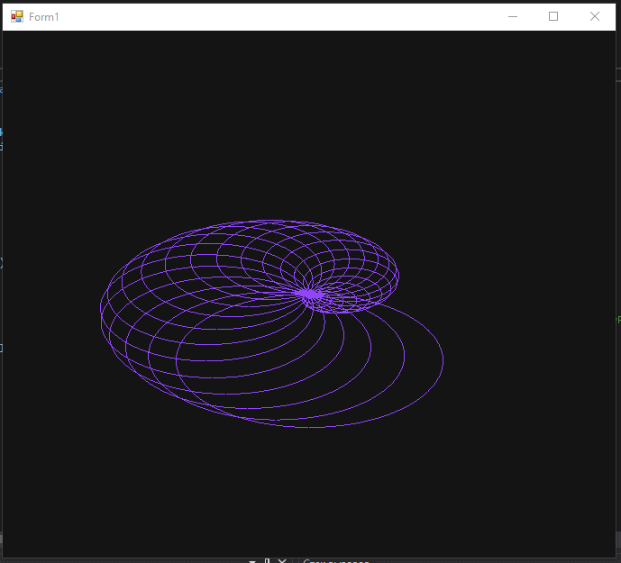
2. 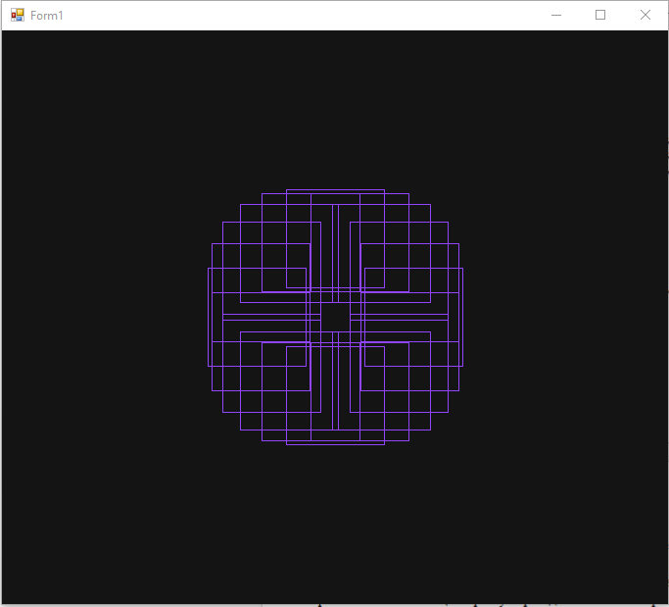
3. 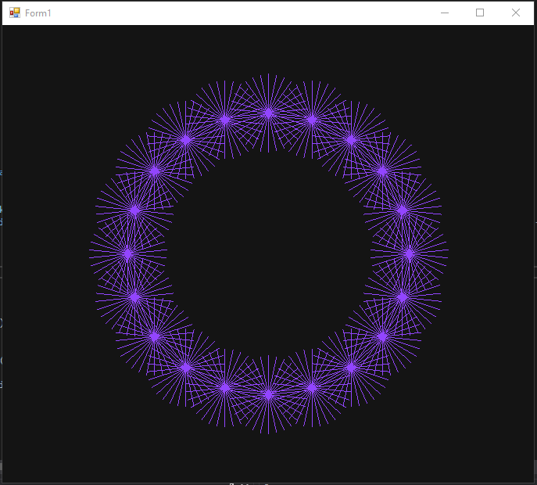
4. 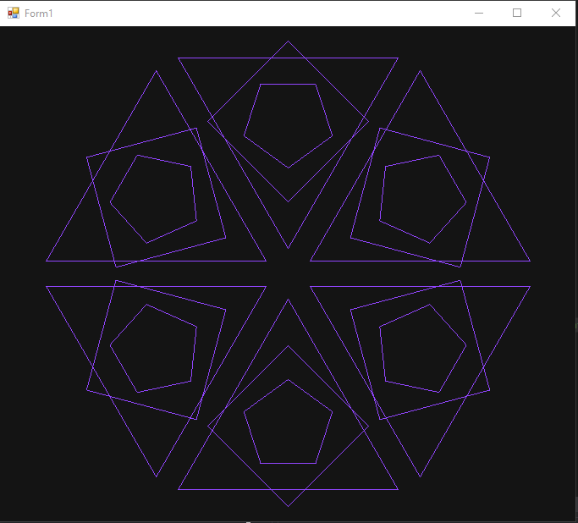
5. 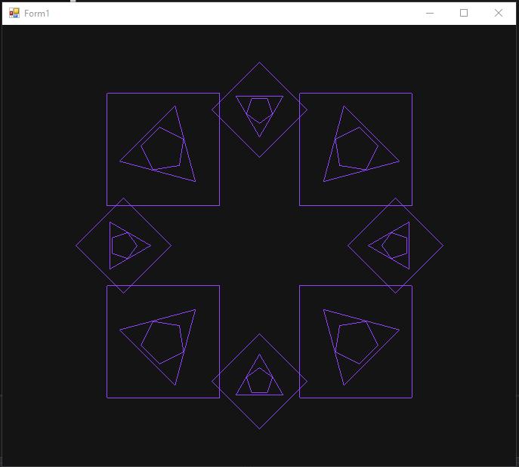
6. 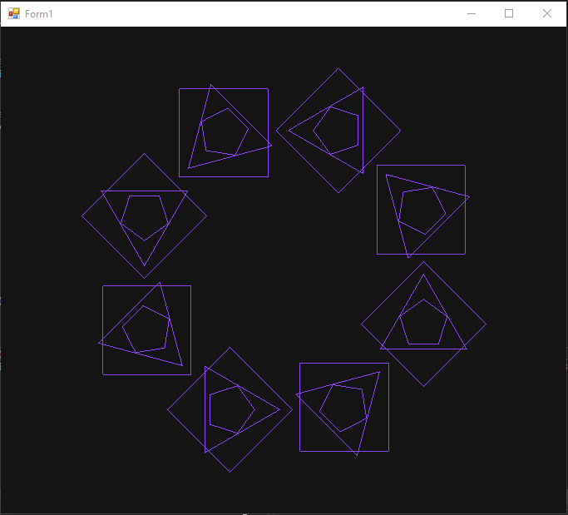
7. 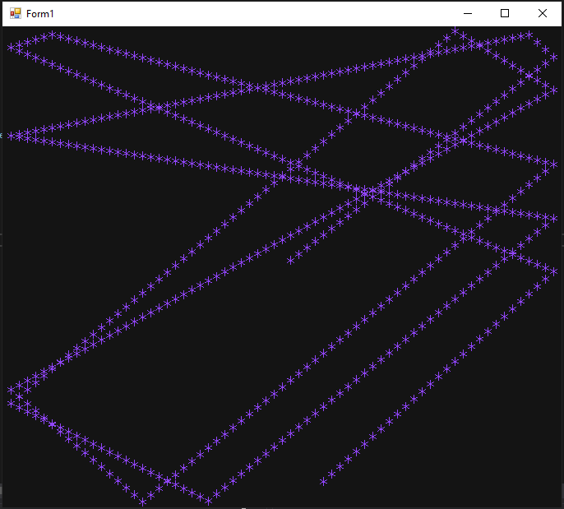
8. 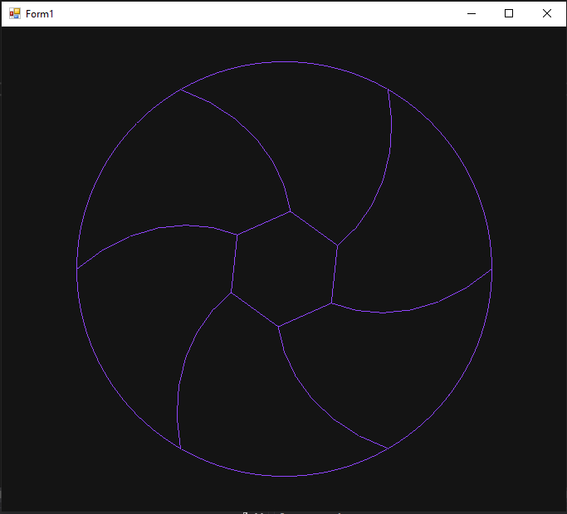
9. 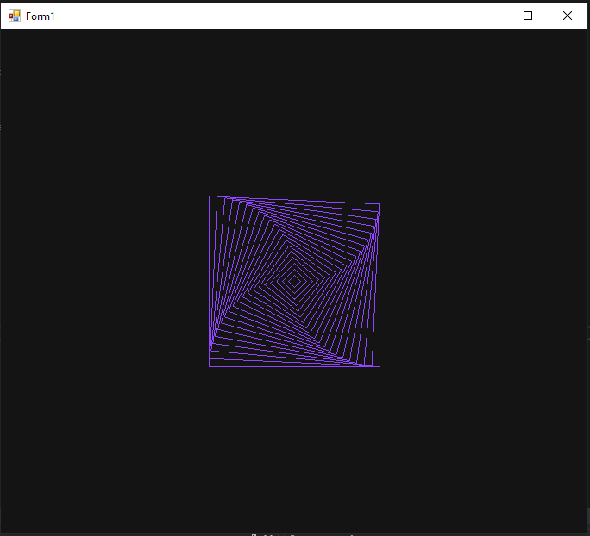
10. 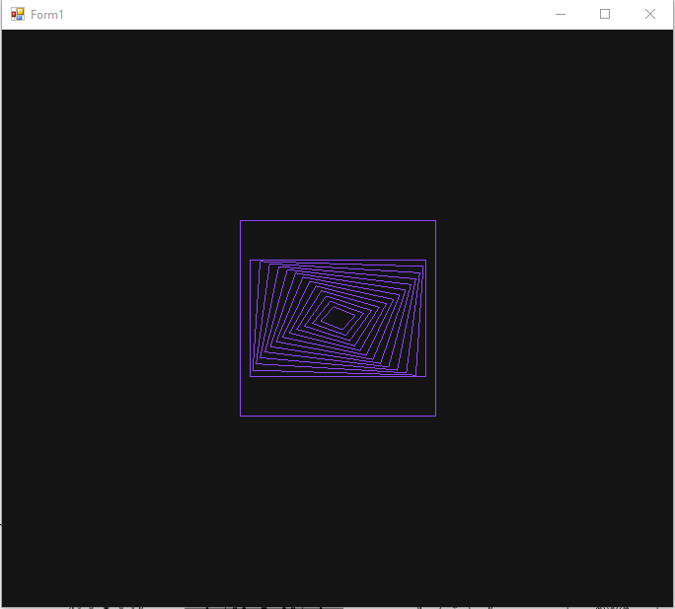
11.
a)
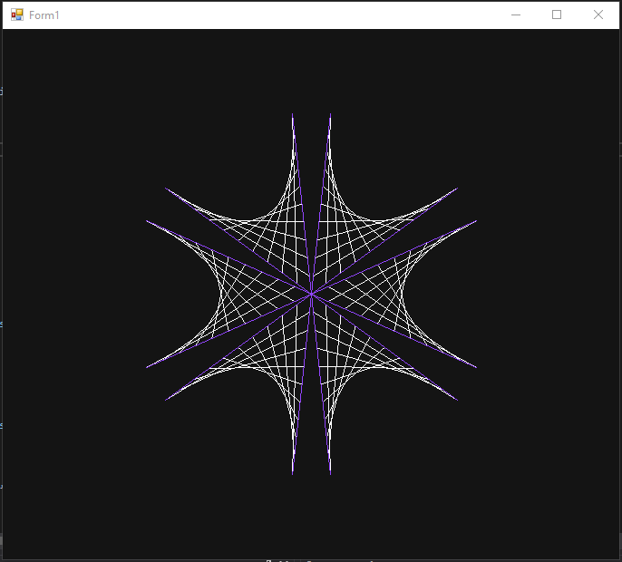
b) 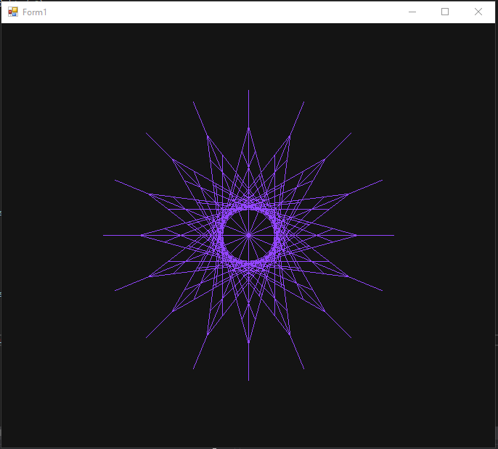
c) 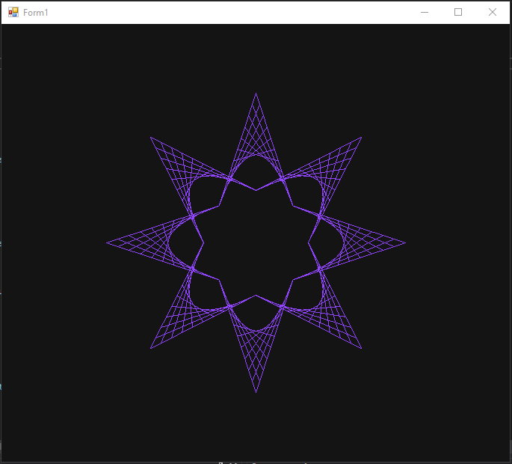
d) 